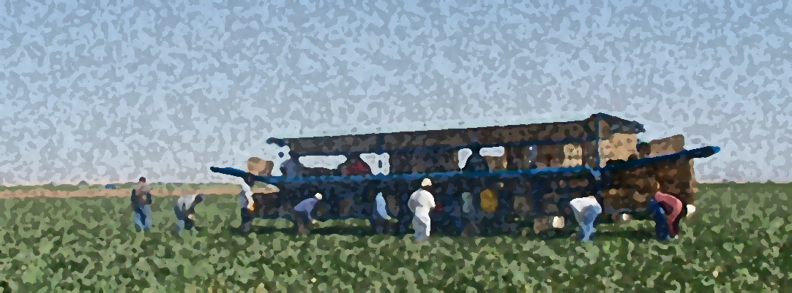

Protections for Arizona Farmworkers: During & After COVID-19

Policy Recommendations

Arizona Public Health Association AZPHA
Arizona Prevention Research Center, University of Arizona
Southeast Arizona Area Health Education Center, SEAHEC
Center for Health Equity Research, Northern Arizona University
Binational Workgroup for the Health and Well-being of Arizona-Sonora Farmworkers
Nogales Binational Health Council
Campesinos Sin Fronteras
Arizona Rural Health Association AZRHA

December 2020

WORKING CONDITIONS IN AGRICULTURE FACILITATE THE SPREAD OF COVID
We hope this guide serves Arizona leadership with the critical information to make urgent policy changes that ensure the safety of every Arizonan. It is almost certain that there will continue to be a large spread of COVID in agriculture that has the potential to affect many Arizonans living in rural areas who already face many barriers to health services. Since March, Arizona has experienced almost 6,500 deaths, and over 302,000 cases of COVID-19. As is often the case, rural communities are hardest hit due to limited access to health services and providers.
Arizona’s farmworkers are essential workers. Yet, their industry is highly vulnerable to COVID-19 illness (and other contagious illnesses) because they work in close quarters, where physical distancing is difficult, they are often not provided with protective gear from their employers, and many travel to work side by side in vans and other vehicles. Most are low-income who lack access to medical care and paid sick leave. Many are here on temporary visas, contingent on their agricultural employment. They cannot afford to miss work when ill and fear losing their jobs and visas if they complain about unsafe or unhealthy working conditions. At the same time, farmworker communities lack access to health education and screening services. These factors combine to make agricultural work a perfect vector for spreading diseases, including COVID.
Agriculture is of crucial economic importance for Arizona, with an estimated 15,500 agricultural farms totaling over 26 million acres of land. Arizona grows much of the lettuce, melons, and animal forage that circulates throughout the United States.
REPORTS OF COVID HOT SPOTS IN ARIZONA RURAL AGRICULTURAL COMMUNITIES
It is well documented that agricultural workers have been devastated by COVID-19 across the nation, with hundreds of workers sick and dying, including in communities of Florida, Washington, Oregon and Georgia. Arizona has not been spared. Specifically, in Cochise County, there have been deaths attributed to COVID at two agricultural facilities including the death of community health workers. Yuma County is no exception, in the last several months they have experienced over 16,800 cases and over 370 deaths.
ABSENCE OF WORKER PROTECTIONS HINDERS ACCESS TO HEALTH CARE
Most agricultural workers in the U.S. lack many of the basic employment benefits that employees in other professions enjoy, including health insurance, sick leave and unemployment insurance. Recently, there have even been policy proposals to lower the wages of agricultural workers – in the midst of this pandemic. Many farmworker families, including migrant workers, are the economic mainstay for their extended families here and abroad on poverty wages. The consequences of missing work or complaining about working conditions are high, especially for those whose visas are tied to employment.
Therefore, workers who become ill with COVID-19 (or other infectious diseases) often do not seek medical attention because they lack financial resources or fear losing their jobs. Missing work for a day or an entire paycheck means the difference being able to feed their families or go hungry, despite that their work brings food to the rest of our families in Arizona and the U.S.

ARIZONA CAN ACT NOW TO PROTECT OUR AGRICULTURAL WORKERS
Given the high level of infection worldwide, nationally and the continued spread statewide, Arizona is well-positioned among the leaders of states that have moved forward with implementing protective recommendations. These recommendations can protect not only the farmworker but promote Arizona’s public health, the stability of our food supply and agricultural industry’s bottom line. Without these steps, our rural health care providers, already overburdened and in short supply, are soon to be overrun.
As Arizona health care providers, professionals, and residents of these communities we ask for your leadership in promoting the following preventive measures among farmworker employers to Implement COVID-19 Workplace Protections.
  - Social distancing – to extent feasible, employers should plan work crew activity to ensure proper distancing to avoid unnecessary transmission of disease at work. As well, sufficient vehicles must be available to transport workers to work so that workers are not sitting directly next to other workers.
  - Face masks – require that all workers are provided free of charge cotton face masks by the employer.
  - Hand sanitizing, hand washing and gloves – workers must have the ability to wash hands with soap and water regularly. Employers must provide hand sanitizer that are readily available in multiple locations in the workplace. Gloves should be provided to workers who request them.
  - Regular disinfection – employers must disinfect regularly all frequently touched surfaces in the workplace (touchscreens, telephones, handrails, doorknobs).
  - Increase ventilation rates – increase % outdoor air that circulates in the system.
  - Notification of workers – employers must inform workers of potential workplace exposure to a positive COVID-19 case within 24 hours while keeping infected persons identity confidential.
  - Deep cleaning after confirmed cases – if the worker is suspected or confirmed to have COVID-19, employers shall close off workplace areas visited by the ill person. Open outside doors and windows and use fans to increase circulation. Wait 24 hours or as long as practical and then conduct cleaning.
  - Require employers to inform workers about covid-19 concerns. All workers will be advised about risks of COVID, how employers will protect their safety while transporting and employing them.

For more information contact:

Gail Emrick, MPH, gemrick@seahec.org
Maia Ingram MPH, maiai@email.arizonaedu, or
Jill Guernsey de Zapien dezapien@email.arizona.edu
Emma Torres etorres@campesinossinfronteras.org

